**Chapter 1**

**Introduction**

**RESTAURANT & FOOD MANAGEMENT is web application for restaurant management. This system make to provide service facility to restaurant and also to the customer. The services that are provided is food ordering and reservation table management by the customer through the system, customer information management and menu information management and report. Main objective build the system this is to provide ordering and reservation service to the customer by online. With this system, ordering and reservation management will become easier and system place traditional system where are still using paper. Further more, this system is applicable anytime and anywhere for customers. During the development of the methodology being used is Agile model. Each process during the development process is followed by each phases in Agile model. Software and hardware used are Wamp server ,Notepad ++ and MySQL database. Further more, this project will develop for restaurants management and enhance business in food system business . Others, this project is facilitate customer for make Online order.**

**1.1 Purpose**

The traditional way of maintaining details of a user in a Restaurant was to enter the details and record them. Every time the user need to perform some transactions he has to go to Restaurant and perform the necessary actions, which may not be so feasible all the time. It may be a hard-hitting task for the users and the Restauranters too. The project gives real life understanding of Restaurant & Food Management and activities performed by various roles in the supply chain. Here, we provide automation for Restaurant System through Internet. Restaurant & Food Management project captures activities performed by different roles in real life Restaurant System which provides enhanced techniques for maintaining the required information up to-date, which results in efficiency. The project gives real life understanding of Restaurant & Food Management and activities performed by various roles in a supply chain.

**1.2 Scope**

The scope of the project is the system on which the software is installed, i.e. the project is developed as a desktop application, and it will work for a particular financial institute. And it is used world wide.

**1.3 Existing system**

* In existing system customer need to visit restaurant physically which is vary time consuming process.
* In existing situation we face few troubles like misunderstanding while we order(from customer point of view)
* Restaurant have difficulty to manage their customers and their orders,our system helps to manage customer and restaurant in very easy way.
* In existing system,some time people come to restaurant but there tables are already booked by other people and they come back to our home without eating any food .
* Restaurants owner’s cant publish there services and offers on website so customer cant order by single click.

**Chapter 2**

**Technology/Platform to be used**

**2.1Introduction To HTML**

One language that is specially designed to convert the simple text into Hypertext is known as Hypertext Markup Language (HTML). HTML is the collection of some codes (typically known as tags) that have some special meanings. Each HTML tag has a proper effect on the simple text. Any HTML document is fully portable and can be understood by any browser.

**2.1.1Features of HTML:**

It is the language which can be easily understand and can be modified.

It provides the more flexible way to deign web pages along with the text.

Links can also be added to the web pages so it help the readers to browse the information of their interest.

We can display HTML documents on any platforms such as Windows and Linux etc.

We can insert images, links and relative paths from the Workspace.

Graphics ,videos and sounds can also be added to the web pages which give an extra attractive look to your web pages.

**2.2Introduction To PHP**

PHP (recursive acronym for PHP: Hypertext Preprocessor) is a widely-used open source general-purpose scripting language that is especially suited for web development and can be embedded into HTML. PHP is a server side scripting language that is embedded in HTML. It is used to manage dynamic content, databases, session tracking, even build entire e-commerce sites. It is integrated with a number of popular databases, including MySQL ,Oracle, Sybase and Microsoft SQL Server.

**2.2.1Common uses of PHP:**

PHP can handle forms, i.e. gather data from files, save data to a file, thru email you can send data, return data to the user.

You add, delete, modify elements within your database thru PHP.

Access cookies variables and set cookies.

Using PHP, you can restrict users to access some pages of your website.

**2.2.2Usage**

PHP is a general-purpose scripting language that is especially suited to [server-side](http://en.wikipedia.org/wiki/Server-side_scripting) [web development](http://en.wikipedia.org/wiki/Web_development) where PHP generally runs on a [web server](http://en.wikipedia.org/wiki/Web_server). Any PHP code in a requested file is [executed](http://en.wikipedia.org/wiki/Execution_%28computing%29) by the PHP runtime, usually to create [dynamic web page](http://en.wikipedia.org/wiki/Dynamic_web_page) content or dynamic images used on Web sites or elsewhere. It can also be used for [command-line](http://en.wikipedia.org/wiki/Command-line) scripting and [client-side](http://en.wikipedia.org/wiki/Client-side) [GUI](http://en.wikipedia.org/wiki/Graphical_user_interface) applications. PHP can be deployed on most Web servers, many [operating systems](http://en.wikipedia.org/wiki/Operating_system) and [platforms](http://en.wikipedia.org/wiki/Platform_%28computing%29), and can be used with many [relational database management systems](http://en.wikipedia.org/wiki/Relational_database_management_system) (RDBMS). It is available free of charge, and the PHP Group provides the complete source code for users to build, customize and extend for their own use.

PHP acts primarily as a [filter](http://en.wikipedia.org/wiki/Filter_%28software%29), taking input from a file or stream containing text and/or PHP instructions and outputting another stream of data; most commonly the output will be HTML. Since PHP 4, the PHP [parser](http://en.wikipedia.org/wiki/Parser) [compiles](http://en.wikipedia.org/wiki/Compiler) input to produce [code](http://en.wikipedia.org/wiki/Bytecode) for processing by the [Zend Engine](http://en.wikipedia.org/wiki/Zend_Engine), giving improved performance over its [interpreter](http://en.wikipedia.org/wiki/Interpreter_%28computing%29) predecessor.

**2.3Introduction To CSS**

**C**ascading **S**tyle **S**heets, fondly referred to as CSS, is a simple design language intended to simplify the process of making web pages presentable.CSS handles the look and feel part of a web page. Using CSS, you can control the color of the text, the style of fonts, the spacing between paragraphs, how columns are sized and laid out, what background images or colors are used, layout designs ,variations in display for different devices and screen sizes as well as a variety of other effects.

CSS is easy to learn and understand but it provides powerful control over the presentation of an HTML document. Most commonly, CSS is combined with the markup languages HTML or XHTML.

**2.4Introduction To jQuery**

The purpose of jQuery is to make it much easier to use JavaScript on your website. jQuery is a lightweight, "write less, do more", JavaScript library. The purpose of jQuery is to make it much easier to use JavaScript on your website. jQuery takes a lot of common tasks that require many lines of JavaScript code to accomplish, and wraps them into methods that you can call with a single line of code. jQuery also simplifies a lot of the complicated things from JavaScript, like AJAX calls and DOM manipulation.

**2.5Introduction To Javascript**

In spite of the similarity of names, JavaScript is not Java. The languages are not related. Java is frequently used to program games, mobile phones, and other devices, such as the Amazon Kindle. Although Java can be used in websites, it's rarely used that way.

JavaScript, on the other hand, is a lightweight, yet powerful language that normally runs inside a web browser. Its role is to provide access to different elements of the page so that they can be removed or updated. It can also create new elements, change the style of existing elements, or extract information from them.

**2.6Introduction To SQL**

SQL (Structured Query Language) is a computer language used to store, manipulate, and retrieve data stored in databases. The first manifestation of SQL appeared in 1974, when a group in IBM developed the first sample of a relational database. The first commercial relational database was released by Relational Software. Standards for SQL exist. However, the SQL that can be used on each one of the major RDBMS today is in different flavors.

SQL is short for Structured Query Language and is a widely used database language, providing means of data manipulation (store, retrieve, update, delete) and database creation.

Almost all modern Relational Database Management Systems like MS SQL Server, Microsoft Access, MSDE, Oracle, DB2, Sybase, MySQL, Postgres and Informix use SQL as standard database language. Now a word of warning here, although all those RDBMS use SQL, they use different SQL dialects. For example MS SQL Server specific version of the SQL is called T-SQL, Oracle version of SQL is called PL/SQL, MS Access version of SQL is called JET SQL, etc.

**Chapter 3**

**Problem Statement**

Nowadays, many restaurants manage their business by manual especially take customer ordering. Today, restaurant waiter takes the customer ordering by manual system with using paper. This is problem for restaurant waiter the probability lost and duplicates customer information. Additionally, it would affect to reputation restaurant in operate management of ordering. hides, the restaurant waiter information also by manual system kept use paper and this is difficult for restaurant administrator to find waiter information, probability missing the paper and difficult to arrange the schedule. Sometimes, waiter information and customer information is important to restaurant administrator for reference in the future. Furthermore, restaurant side needs management in the section menu. This is the important to restaurant waiter to manage the menu. Besides this section is for customer viewer the menu that restaurant prepared and make their ordering. As a result, the current system (manual system) is not effective and efficient to use anymore because the current system cannot save, manage and monitor the restaurant waiter information, menu customer ordering and generate report well.

**Objective Based on the problems stated above, the objectives of the project are:**

1. to develop online ordering and reservation system in restaurant

2. to develop use interface for online restaurant management system

3. to provide online menu information for customer

**3.1 Scope**

This section consist of three components which is target user, target area and project deliverables.

**3.1.1 Target User**

The groups of user that had been identified to use the system are customer and administrator. Customer This user will register to be a member to use the online system of this online restaurant management system (ORMS). This online ordering divided into two type of customw, it is customer dine-in ordering and takeaway ordering. For ordering, customer will view menu, make online ordering and make a reservation table. But takeaway ordering, customer can view menu and online ordering without reservation table. After customer make online ordering, customer can take ordering the date that customer was choose during make online ordering. Event though, customer must confirm online ordering with restaurant three days before customer take the ordering for dine-in customer and for take-away customer will be confirm one hour before it whether by email or phone. Administrator is the person who will manage the entire system. This type of user will also do maintenance and control the application of this system. Administrator takes a imponsibility to register new customer, register new waiter, register new menu into database, and etc.

**3.1.2 Target Area**

This system will be placed at restaurant.

**3.1.3 Project Deliverables**

Regarding to the module that had been identified, the flow of an activity will be described in term of customer registration module, customer online ordering and reservation module, waiter module, feedback module, menu module and generate report module. Customer Registration Module Customer registration module contains customer's information such as customer personal information and other information related to that customer. Then, all of this information recorded into database.

**Chapter 4**

**System Development Process**

**4.1. System Analysis**

System analysis is a process of gathering and interpreting facts, diagnosing problems and the information to recommend improvements on the system. It is a problem solving activity that requires intensive communication between the system users and system developers. System analysis or study is an important phase of any system development process. The system is studied to the minutest detail and analyzed. The system analyst plays the role of the interrogator and dwells deep into the working of the present system. The system is viewed as a whole and the input to the system are identified. The outputs from the organizations are traced to the various processes. System analysis is concerned with becoming aware of the problem, identifying the relevant and decisional variables, analyzing and synthesizing the various factors and determining an optimal or at least a satisfactory solution or program of action.

A detailed study of the process must be made by various techniques like interviews, questionnaires etc. The data collected by these sources must be scrutinized to arrive to a conclusion. The conclusion is an understanding of how the system functions. This system is called the existing system. Now the existing system is subjected to close study and problem areas are identified. The designer now functions as a problem solver and tries to sort out the difficulties that the enterprise faces. The solutions are given as proposals. The proposal is then weighed with the existing system analytically and the best one is selected. The proposal is presented to the user for an endorsement by the user. The proposal is reviewed on user request and suitable changes are made. This is loop that ends as soon as the user is satisfied with proposal.

Preliminary study is the process of gathering and interpreting facts, using the information for further studies on the system. Preliminary study is problem solving activity that requires intensive communication between the system users and system developers. It does various feasibility studies. In these studies a rough figure of the system activities can be obtained, from which the decision about the strategies to be followed for effective system study and analysis can be taken.

**4.2. Feasibility Study**

Feasibility study is made to see if the project on completion will serve the purpose of the organization for the amount of work, effort and the time that spend on it. Feasibility study lets the developer foresee the future of the project and the usefulness. A feasibility study of a system proposal is according to its workability, which is the impact on the organization, ability to meet their user needs and effective use of resources. Thus when a new application is proposed it normally goes through a feasibility study before it is approved for development.

The document provide the feasibility of the project that is being designed and lists various areas that were considered very carefully during the feasibility study of this project such as Technical, Economic and Operational feasibilities.

The following are its features:

**4.2.1Technical Feasibility**

The system must be evaluated from the technical point of view first. The assessment of this feasibility must be based on an outline design of the system requirement in the terms of input, output, programs and procedures. Having identified an outline system, the investigation must go on to suggest the type of equipment, required method developing the system, of running the system once it has been designed.

Technical issues raised during the investigation are:

* Does the existing technology sufficient for the suggested one?
* Can the system expand if developed?

The project should be developed such that the necessary functions and performance are achieved within the constraints. The project is developed within latest technology. Through the technology may become obsolete after some period of time, due to the fact that never version of same software supports older versions, the system may still be used. So there are minimal constraints involved with this project. The system has been developed using Php the project is technically feasible for development.

**4.2.2Economic Feasibility**

The developing system must be justified by cost and benefit. Criteria to ensure that effort is concentrated on project, which will give best, return at the earliest. One of the factors, which affect the development of a new system, is the cost it would require.

The following are some of the important financial questions asked during preliminary investigation:

* The costs conduct a full system investigation.
* The cost of the hardware and software.
* The benefits in the form of reduced costs or fewer costly errors.

Since the system is developed as part of project work, there is no manual cost to spend for the proposed system. Also all the resources are already available, it give an indication of the system is economically possible for development.

The project would be beneficial because it satisfies the objectives when developed and installed. All behavioral aspects are considered carefully and conclude that the project is behaviorally feasible.

**4.3. Design**

Design is the first step into the development phase for any engineered product or system. Design is a creative process. A good design is the key to effective system. The term “design” is defined as “the process of applying various techniques and principles for the purpose of defining a process or a system in sufficient detail to permit its physical realization”. It may be defined as a process of applying various techniques and principles for the purpose of defining a device, a process or a system in sufficient detail to permit its physical realization. Software design sits at the technical kernel of the software engineering process and is applied regardless of the development paradigm that is used. The system design develops the architectural detail required to build a system or product. As in the case of any systematic approach, this software too has undergone the best possible design phase fine tuning all efficiency, performance and accuracy levels. The design phase is a transition from a user oriented document to a document to the programmers or database personnel. System design goes through two phases of development: Logical and Physical Design.

**4.3.1 Logical Design**

* The logical flow of a system and define the boundaries of a system. It includes the following steps:
* Reviews the current physical system – its data flows, file content, volumes, Frequencies etc.
* Prepares output specifications– that is, determines the format, content and Frequency of reports.
* Prepares input specifications– format, content and most of the input functions.
* Prepares edit, security and control specifications.
* Specifies the implementation plan.
* Prepares a logical design walk through of the information flow, output, input, Controls and implementation plan.

**4.4Users**

* **Normal User(Not Registered)/**
* **Registered User.**
* **Admin**

**4.5 Module Design**

* Admin Module
* User Module

**Chapter 5**

**Data flow diagram**

In the late 1970s data-flow diagrams (DFDs) were introduced and popularized for structured analysis and design (Gane and Sarson 1979).  DFDs show the flow of data from external entities into the system, showed how the data moved from one process to another, as well as its logical storage.

There are only four symbols:

1. Squares representing external entities, which are sources or destinations of data.
2. Rounded rectangles representing processes, which take data as input, do something to it, and output it.
3. Arrows representing the data flows, which can either, be electronic data or physical items.
4. Open-ended rectangles representing data stores, including electronic stores such as databases or XML files and physical stores such as or filing cabinets or stacks of paper.

The dataflow diagram should contain following elements:

1. Processes
2. Data flow
3. Actors
4. Data-stores

In data flow diagram, processes that transfers the data, dataflow that move actor object that produce and consume data, and stores the data.

**Process:**

Processes are used to transform the data values. in the lowest level they work like pure function. The symbols of processes are:

Process Name

(a)

**Data flow:**

Dataflow is used for the connection. It connects the output of an object to the input for another object or processes. It represents as an intermediate data values within computations. The values are not changed by the data flow. The data flow is represented with the help of arrows as shown:

Process

(b)

**Actors (External entity):**

An active object in the DFD which producing or receiving data flow with values is called actors. Input and output of dataflow are attached with actors. The actors are lie on the boundary of the data flow graph but terminate the flow data as sources and links of data, and so are sometimes called terminators. An actor can be described by a rectangle.

Actor

(c)

**Data stores:**

A data store indicates a passive object within a data flow diagram that stores data for later access. It doesn’t manage by operation but produce any result or data access. A data stores allow value to be accessed in different order than they are generated.

**Level 0 for User**

USER

account

**Level 1 for User**

User

account

Verify

**Normal User**

add-product

User

reservation

**Register User**

reservation

add-prduct

Register User

location

Orderdetail

Orderdetail

cancelorder

**Level 0 for Admin**

Admin

admin

**level 1 for Admin**

All services regarding project

Admin

**DFD of Admin** add-categories

add-product

location

add-categories

Admin

add-product

reservation

orderdetail

statusorder

cancelorder

**Chapter 6**

**Database Design**

A database is an organized mechanism that has the capability of storing information through which a user can retrieve stored information in an effective and efficient manner. The data is the purpose of any database and must be protected.

The database design is a two level process. In the first step, user requirements are gathered together and a database is designed which will meet these requirements as clearly as possible. This step is called Information Level Design and it is taken independent of any individual DBMS.

In the second step, this Information level design is transferred into a design for the specific DBMS that will be used to implement the system in question. This step is called Physical Level Design, concerned with the characteristics of the specific DBMS that will be used. A database design runs parallel with the system design. The organization of the data in the database is aimed to achieve the following two major objectives:

* Data Integrity
* Data independence

Normalization is the process of decomposing the attributes in an application, which results in a set of tables with very simple structure. The purpose of normalization is to make tables as simple as possible. Normalization is carried out in this system for the following reasons.

* + To structure the data so that there is no repetition of data , this helps in saving.
  + To permit simple retrieval of data in response to query and report request.
  + To simplify the maintenance of the data through updates, insertions, deletions.
  + To reduce the need to restructure or reorganize data which new application Requirements arise.

**Relational Database Management System (RDBMS)**

A relational model represents the database as a collection of relations. Each relation resembles a table of values or file of records. In formal relational model terminology, a row is called a tuple, a column header is called an attribute and the table is called a relation. A relational database consists of a collection of tables, each of which is assigned a unique name. A row in a tale represents a set of related values.

**6.1 Relations, Domains & Attributes:**

A table is a relation. The rows in a table are called tulles. Tulle is an ordered set of n elements. Columns are referred to as attributes. Relationships have been set between every table in the database. This ensures both Referential and Entity Relationship Integrity. A domain D is a set of atomic values. A common method of specifying a domain is to specify a data type from which the data values forming the domain are drawn. It is also useful to specify a name for the domain to help in interpreting its values. Every value in a relation is atomic, that is not decomposable.

## Relationships:

Table relationships are established using Key. The two main keys of prime importance are Primary Key & Foreign Key. Entity Integrity and Referential Integrity Relationships can be established with these keys.

* Entity Integrity enforces that no Primary Key can have null values.
* Referential Integrity enforces that no Primary Key can have null values.
* Referential Integrity for each distinct Foreign Key value, there must exist a matching Primary Key value in the same domain. Other key are Super Key and Candidate Keys.
* Relationships have been set between every table in the database. This ensures both Referential and Entity Relationship Integrity.

**6.2 Normalization:**

As the name implies, it denoted putting things in the normal form. The application developer via normalization tries to achieve a sensible organization of data into proper tables and columns and where names can be easily correlated to the data by the user. Normalization eliminates repeating groups at data and thereby avoids data redundancy which proves to be a great burden on the computer resources. These include:

* Normalize the data.
* Choose proper names for the tables and columns.
* Choose the proper name for the data.

**6.2.1 First Normal Form:**

The First Normal Form states that the domain of an attribute must include only atomic values and that the value of any attribute in a tuple must be a single value from the domain of that attribute. In other words 1NF disallows “relations within relations” or “relations as attribute values within tuples”. The only attribute values permitted by 1NF are single atomic or indivisible values.

The first step is to put the data into First Normal Form. This can be donor by moving data into separate tables where the data is of similar type in each table. Each table is given a Primary Key or Foreign Key as per requirement of the project. In this we form new relations for each monatomic attribute or nested relation. This eliminated repeating groups of data.

A relation is said to be in first normal form if only if it satisfies the constraints that contain the primary key only.

**6.2.2 Second Normal Form**

According to Second Normal Form, for relations where primary key contains multiple attributes, no non key attribute should be functionally dependent on a part of the primary key.

In this we decompose and setup a new relation for each partial key with its dependent attributes. Make sure to keep a relation with the original primary key and any attributes that are fully functionally dependent on it. This step helps in taking out data that is only dependant on apart of the key.

A relation is said to be in second normal form if and only if it satisfies all the first normal form conditions for the primary key and every non-primary key attributes of the relation is fully dependent on its primary key alone.

**6.2.3 Third Normal Form**

According to Third Normal Form, Relation should not have a non key attribute functionally determined by another non key attribute or by a set of non key attributes. That is, there should be no transitive dependency on the primary key.

In this we decompose and set up relation that includes the non key attributes that functionally determines other non key attributes. This step is taken to get rid of anything that does not depend entirely on the Primary Key.

A relation is said to be in third normal form if only if it is in second normal form and more over the non key attributes of the relation should not be depend on other non key attribute.

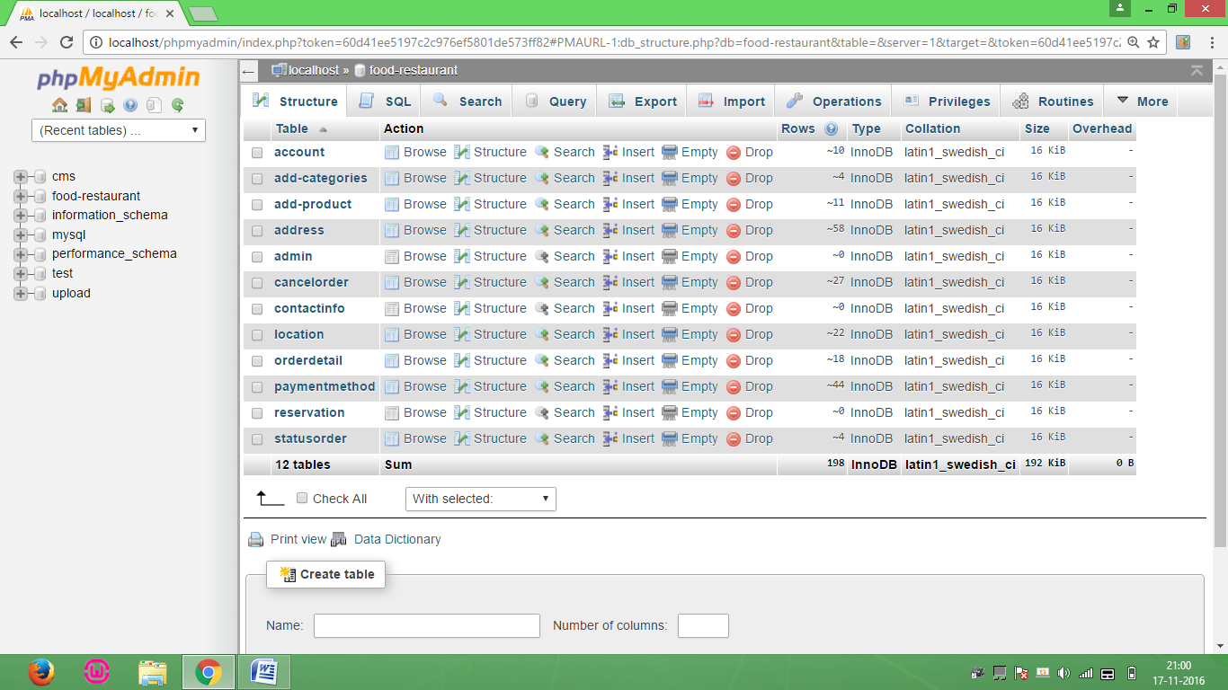database Screen Fig 6.1

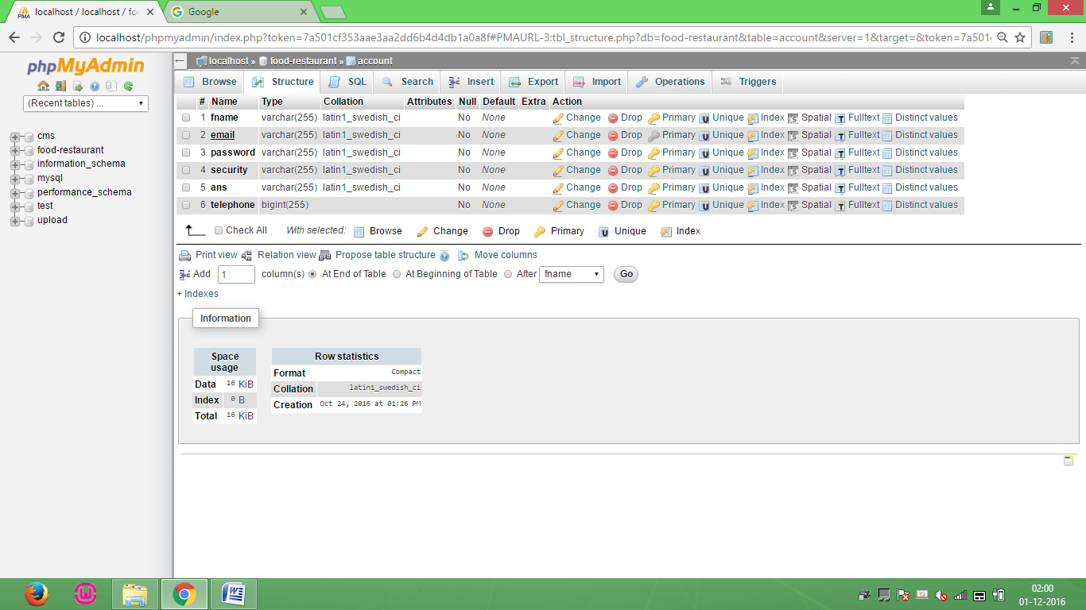account Screen Fig 6.2

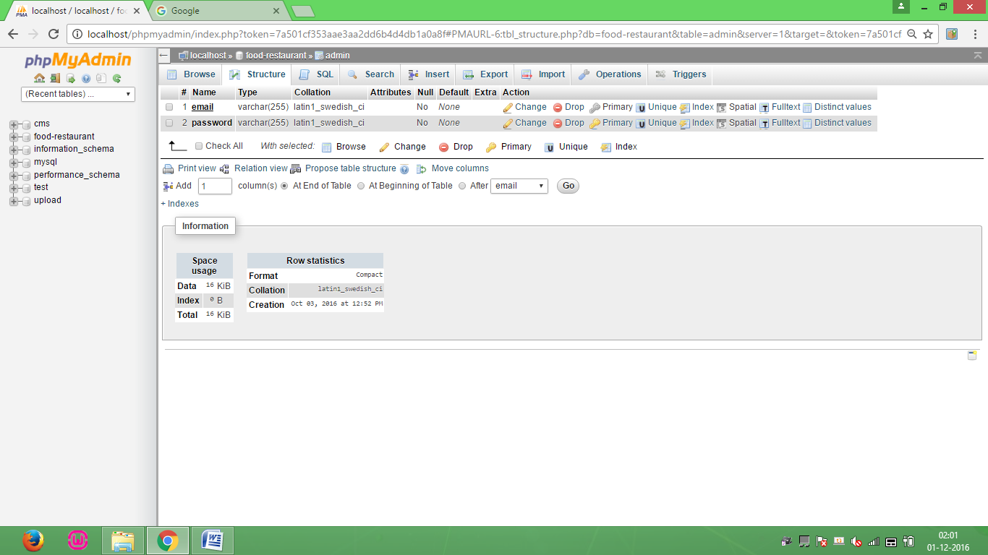admin Screen Fig 6.3

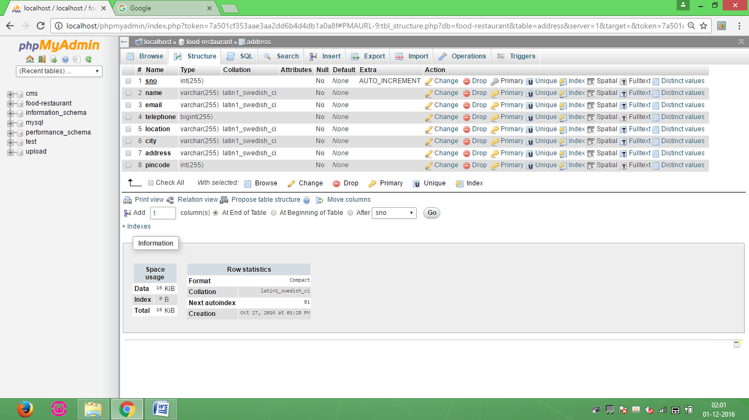address Screen Fig 6.4

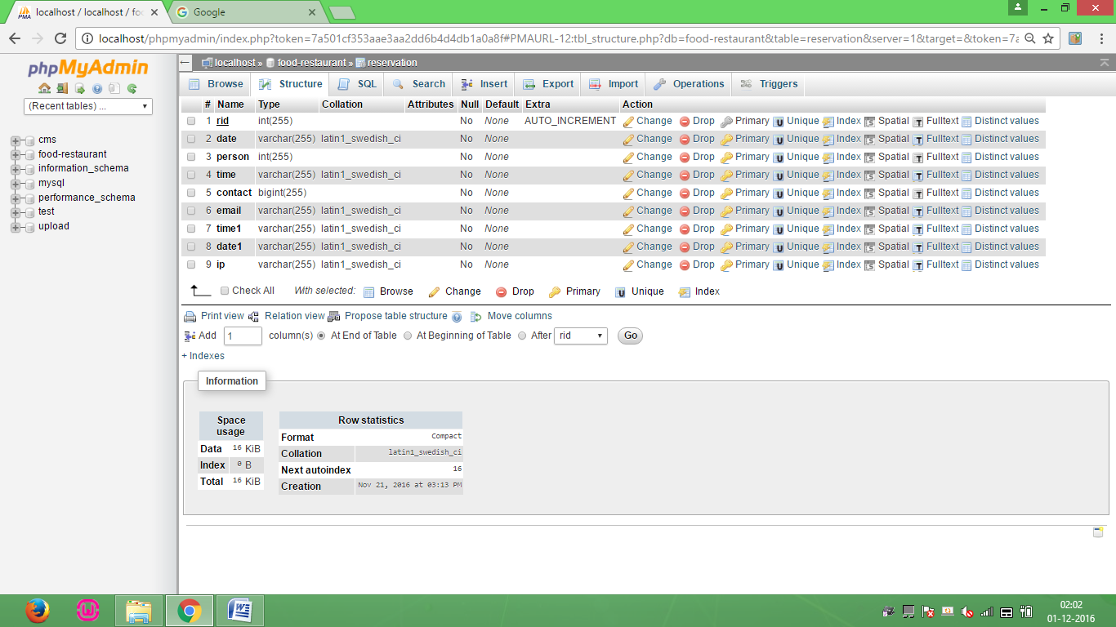reservation Screen Fig 6.5

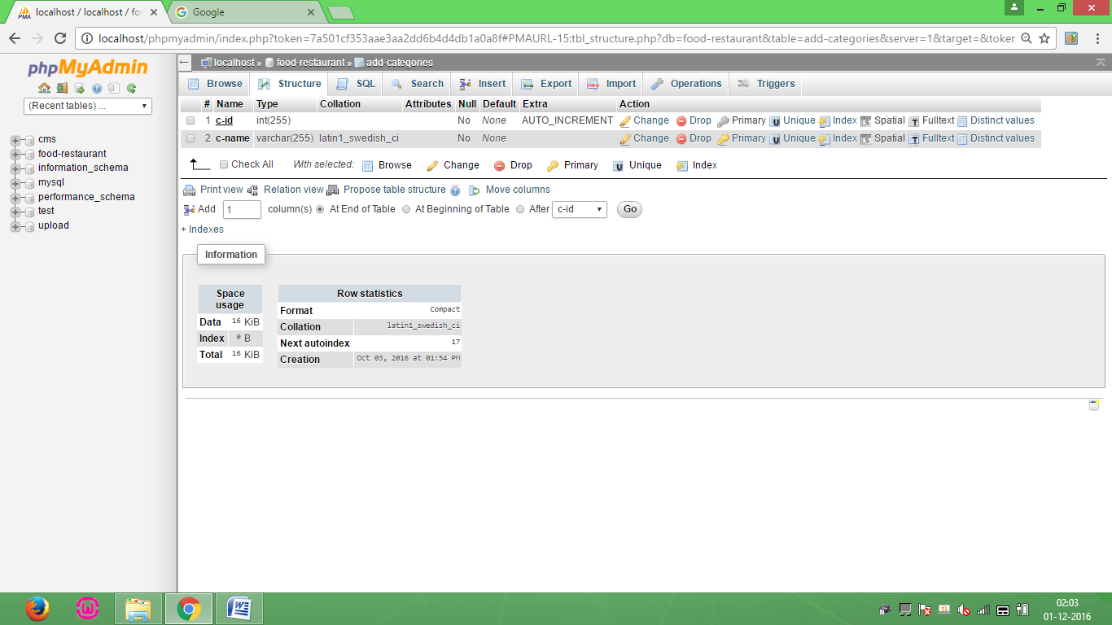add-categories Screen Fig 6.6

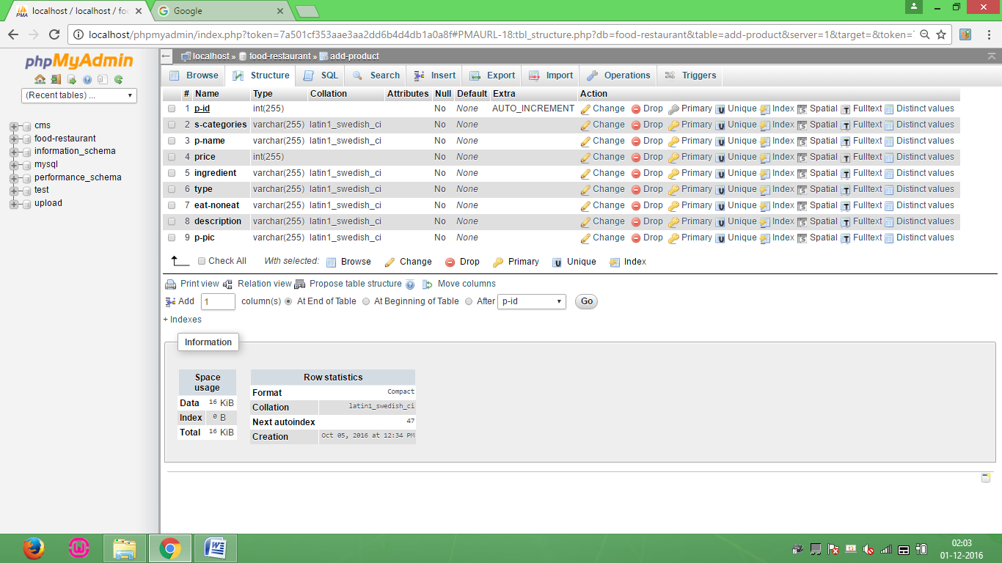add-product Screen Fig 6.7

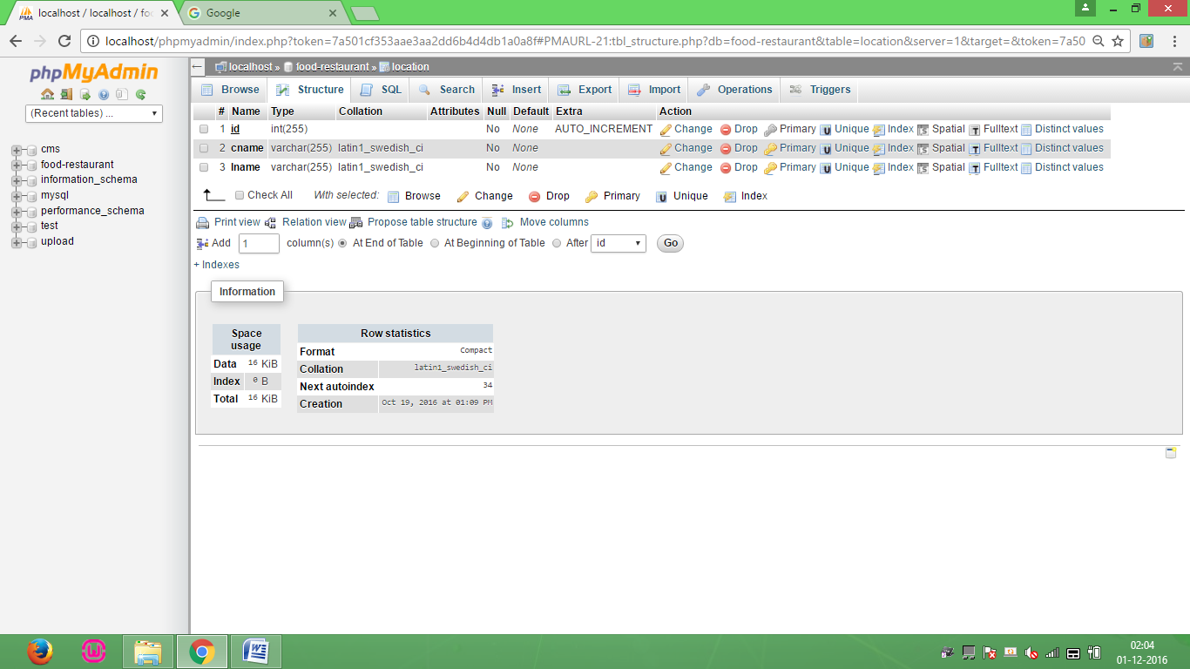location Screen Fig 6.8

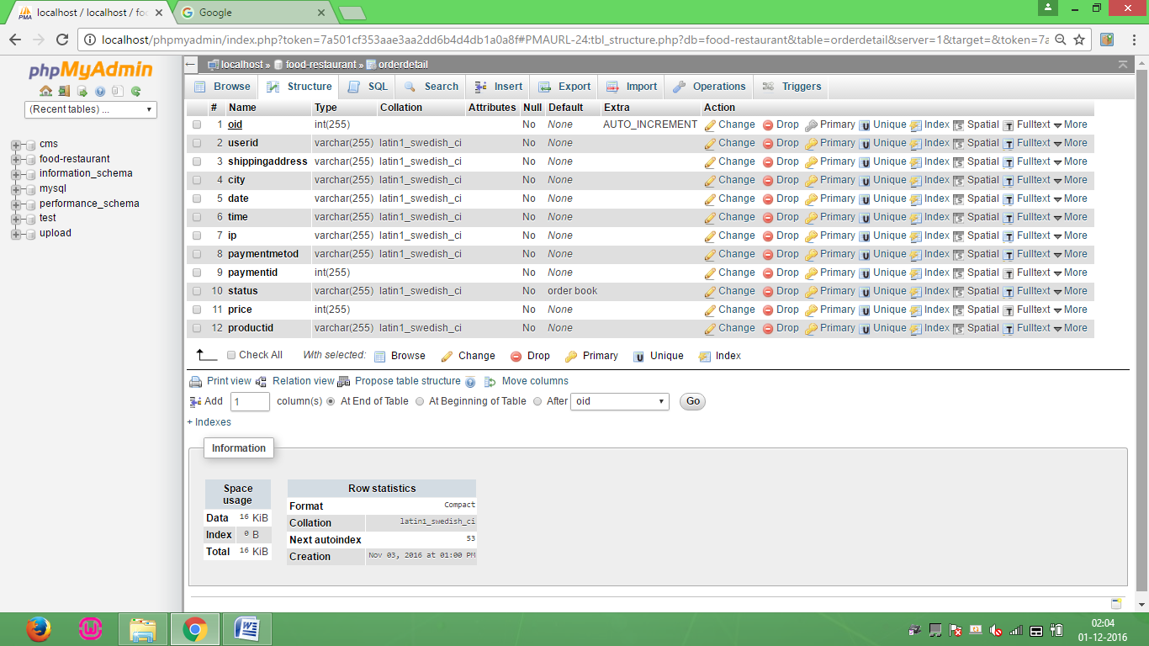orderdetail Screen Fig 6.9

****cancelorder Screen Fig 6.10

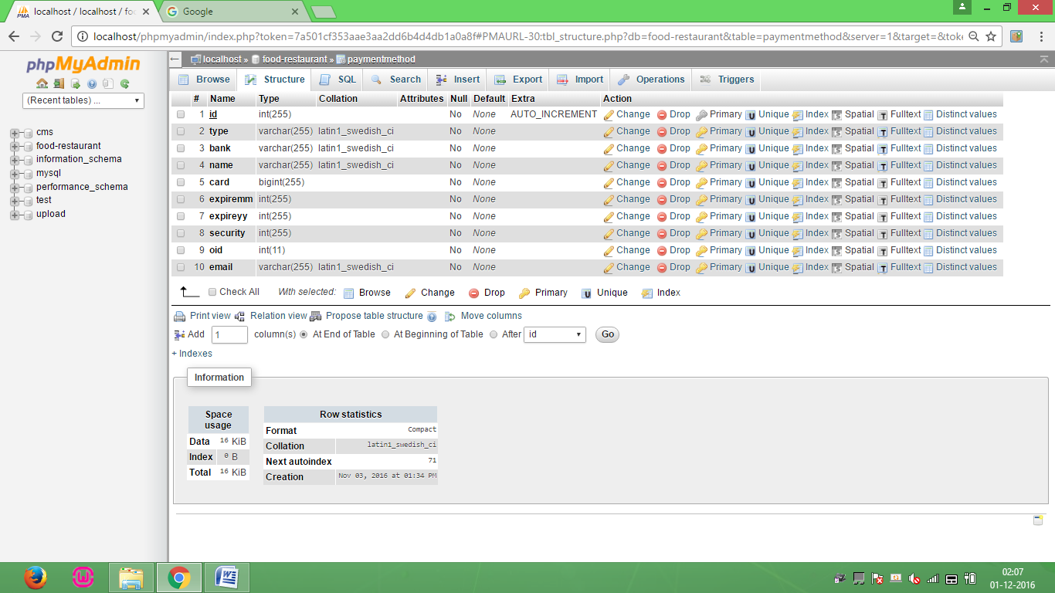paymentmethod Screen Fig 6.11

**Chapter 7**

**Software & Hardware Specifications**

**Software Requirements**

**Front End Tool** **:** PHP

**Web Server :** Wamp Server

**Back End Tool :** MYSQL 4.6.12

**Browser :** Mozilla Firefox /Chrome etc

**Operating System :** Windows Operating System

**To Developed :** Notepad ++

**Hardware Requirements**

**Processor** **:** Intel(R)core(TM)i3-3120M

**RAM**  **:** 512 MB or higher

**Hard Disk**  **:** 80 GB or higher

**Chapter 8**

**Screen Shots**

**Home page**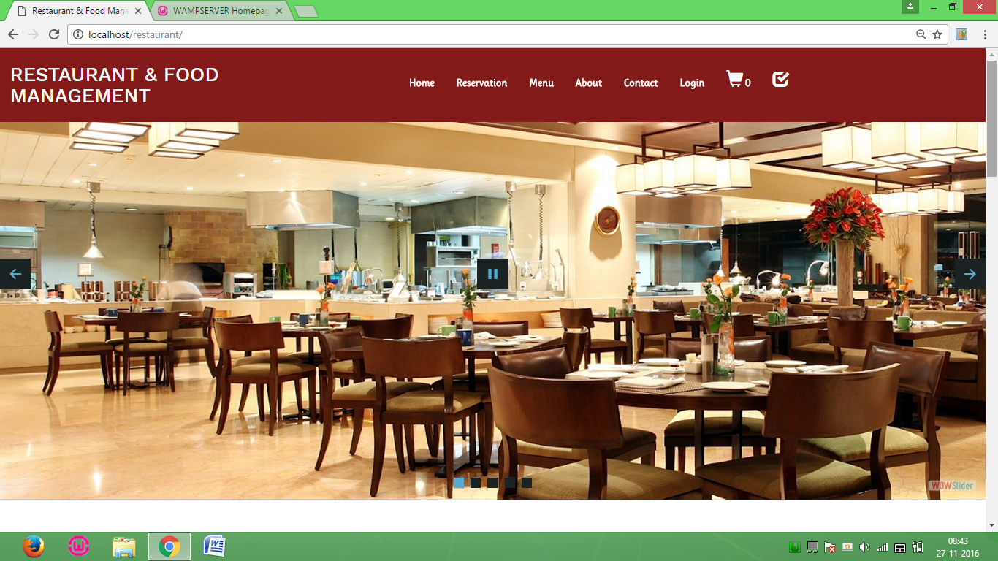Home Screen Fig 8.1

**User Login Form**

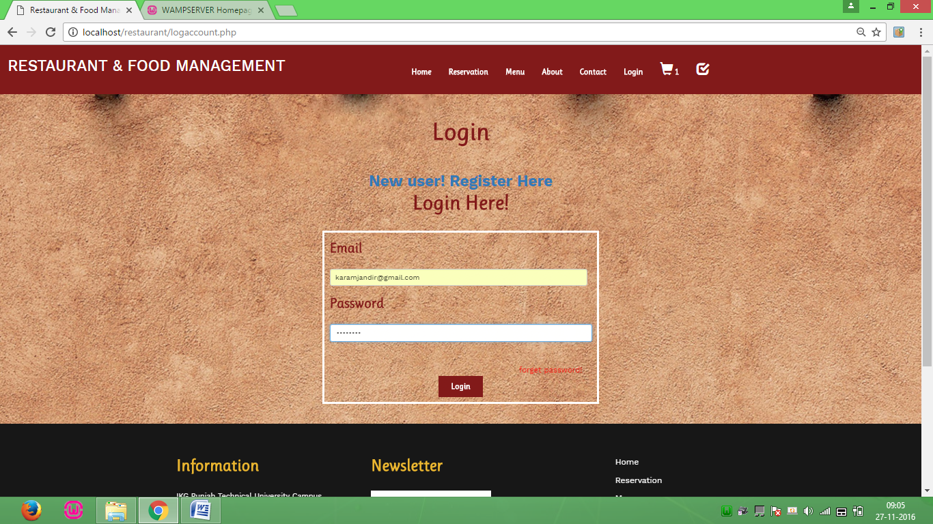User Login Form Screen Fig 8.2

**User Create Account Form**

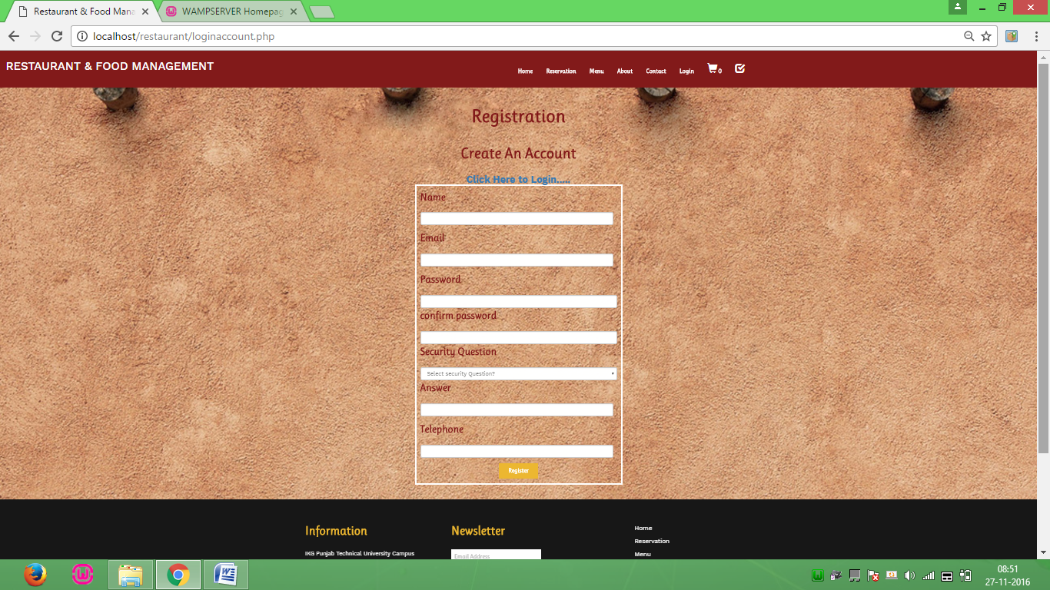User create Account Form Screen Fig 8.3

**Menu Page**

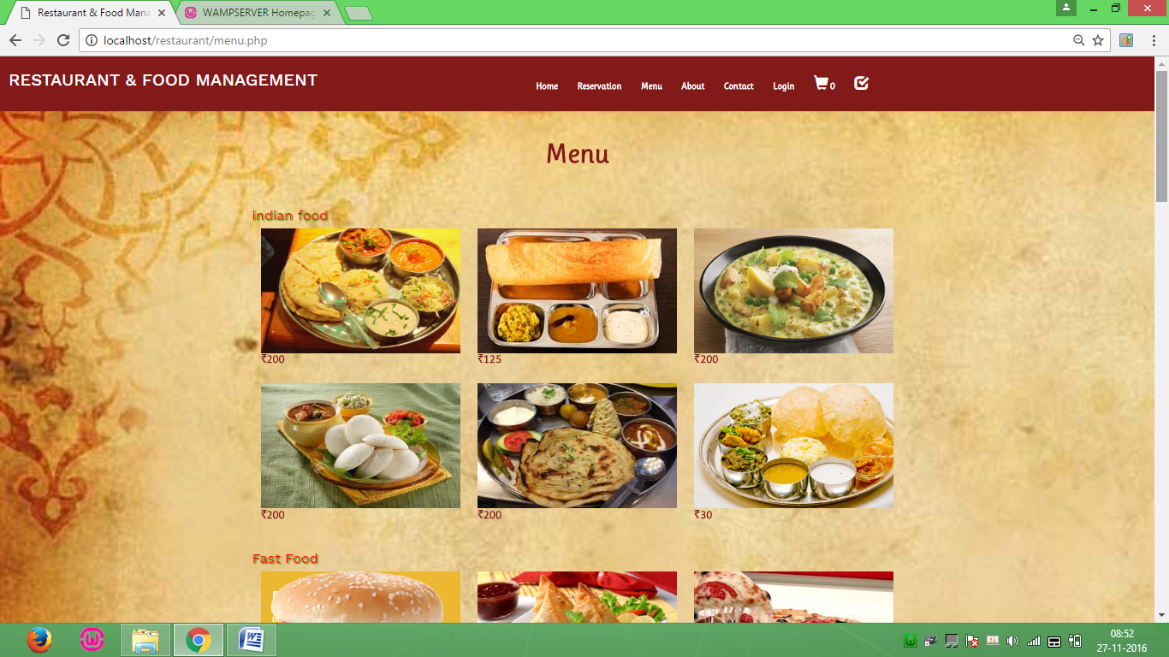Menu Page Screen Fig 8.4

**Description Page**

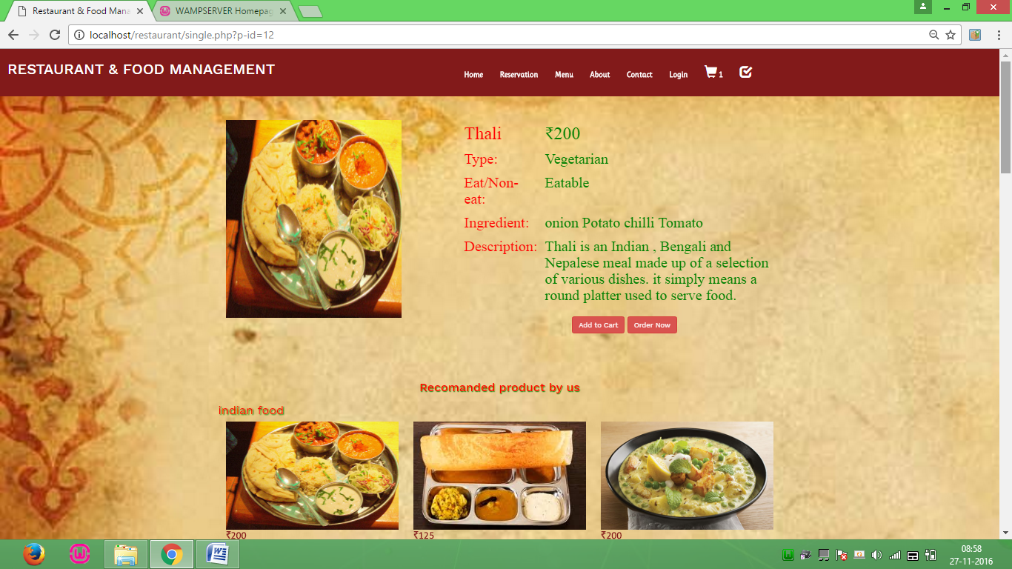Description Page Screen Fig 8.5

**Add Location**

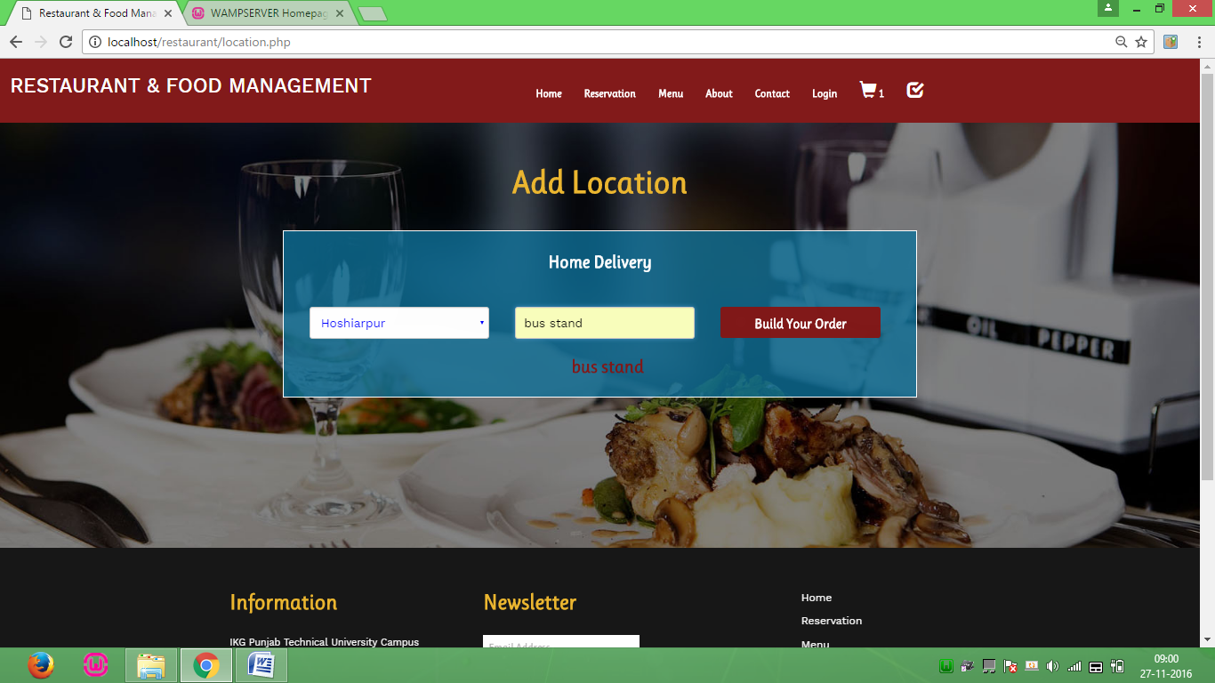Add Location Screen Fig 8.6

**Enter Detail**

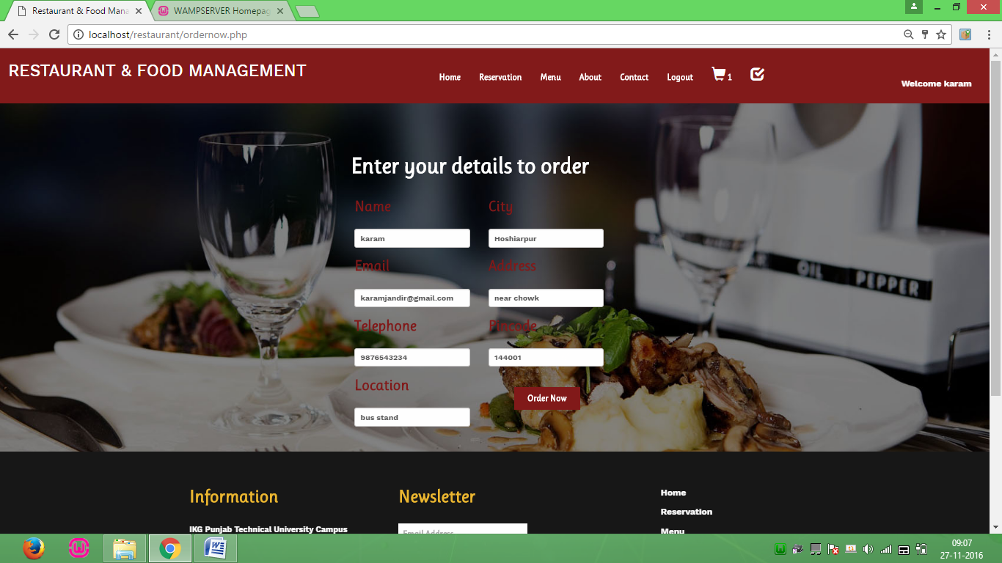Enter Detail Screen Fig 8.7

**Checkout Page**

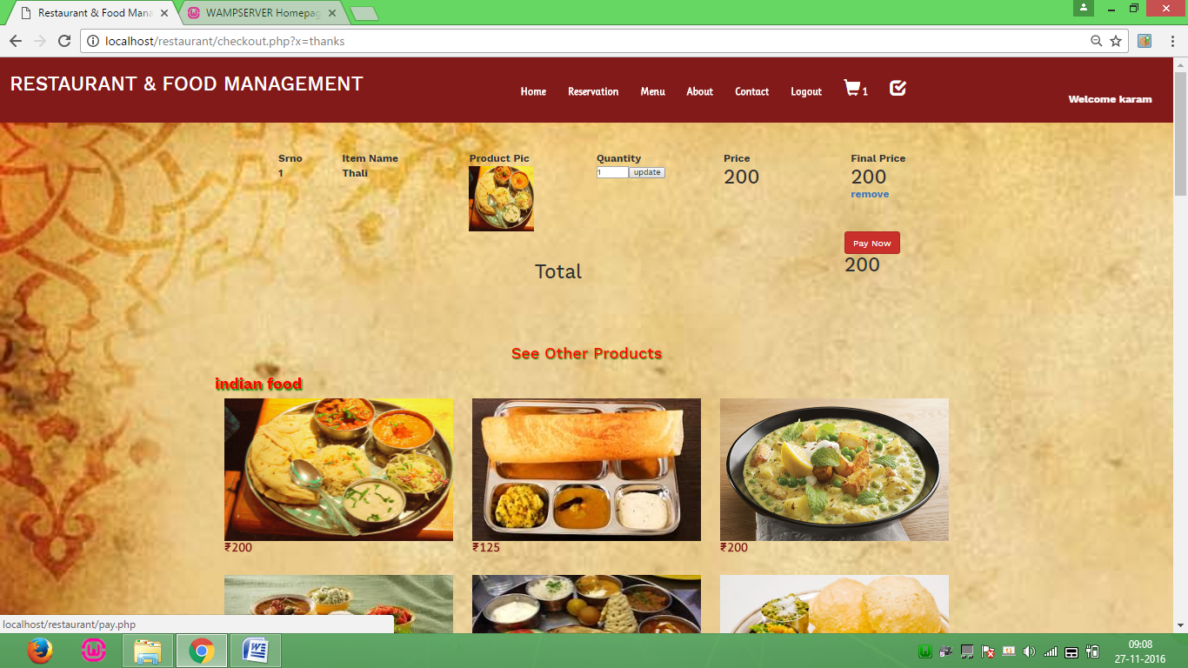Checkout Page Screen Fig 8.8

**Select Payment**

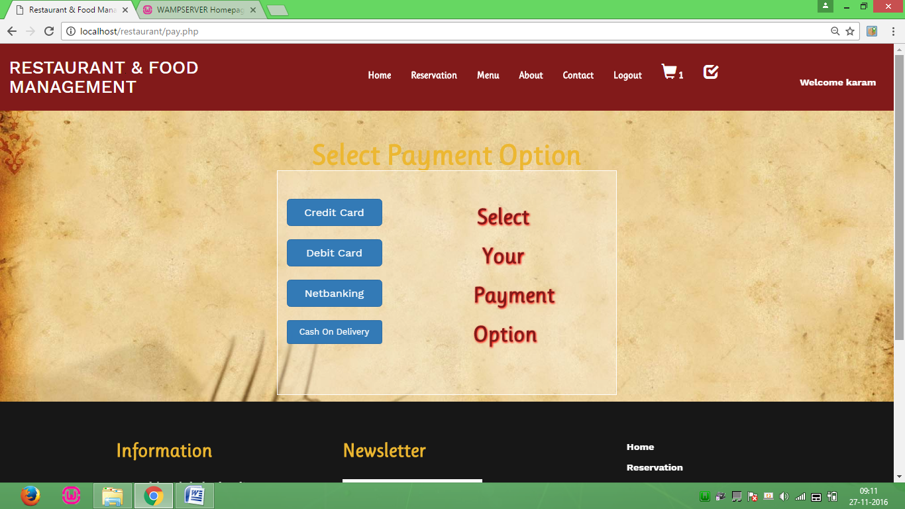Select Payment Screen Fig 8.9

**Shipping Page**

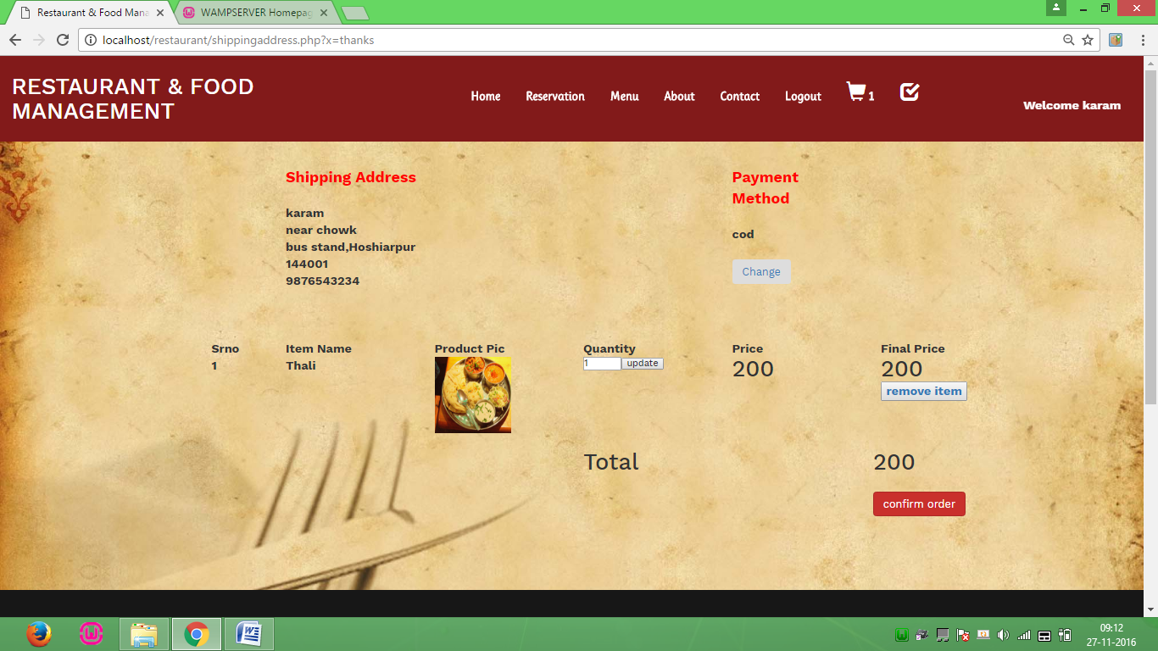Shipping Page Screen Fig 8.10

**Check Previous order**

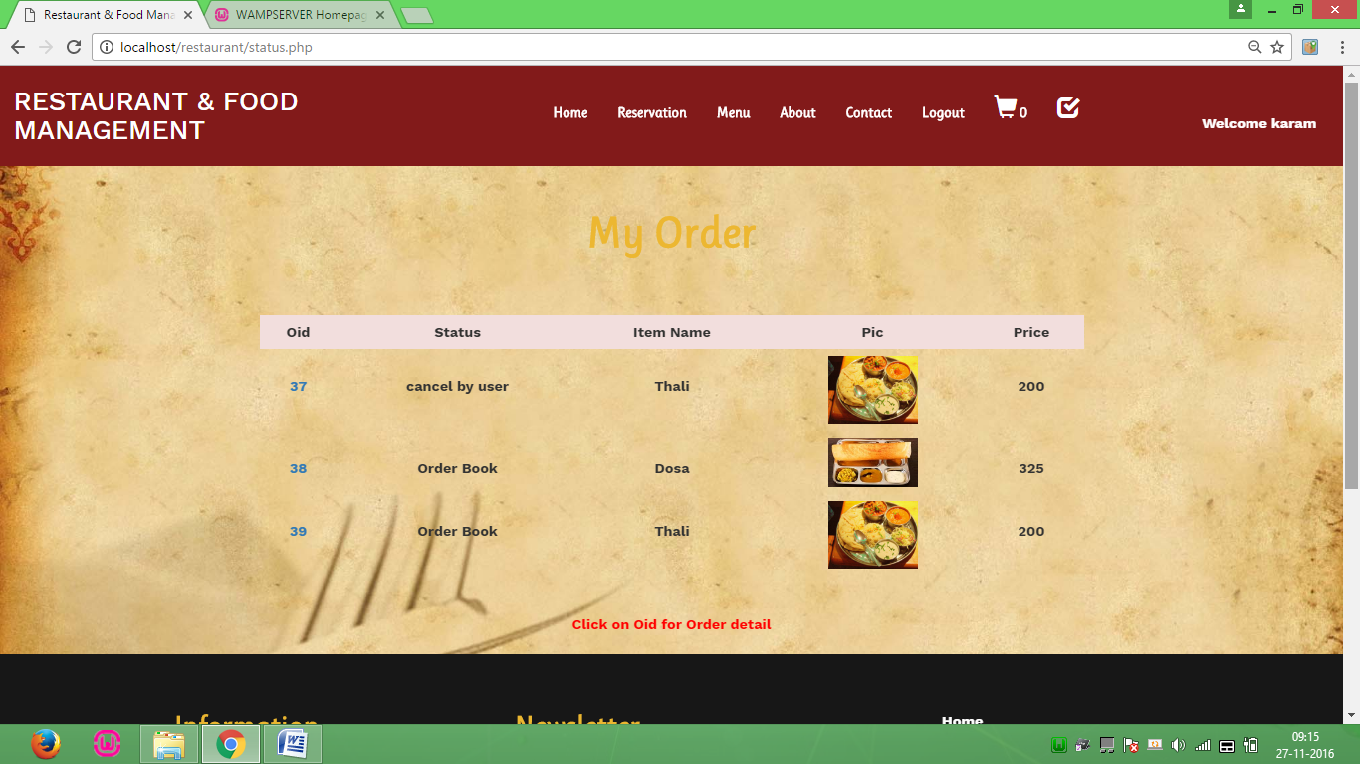Check Previous Order Screen Fig 8.11

**Cancel order**

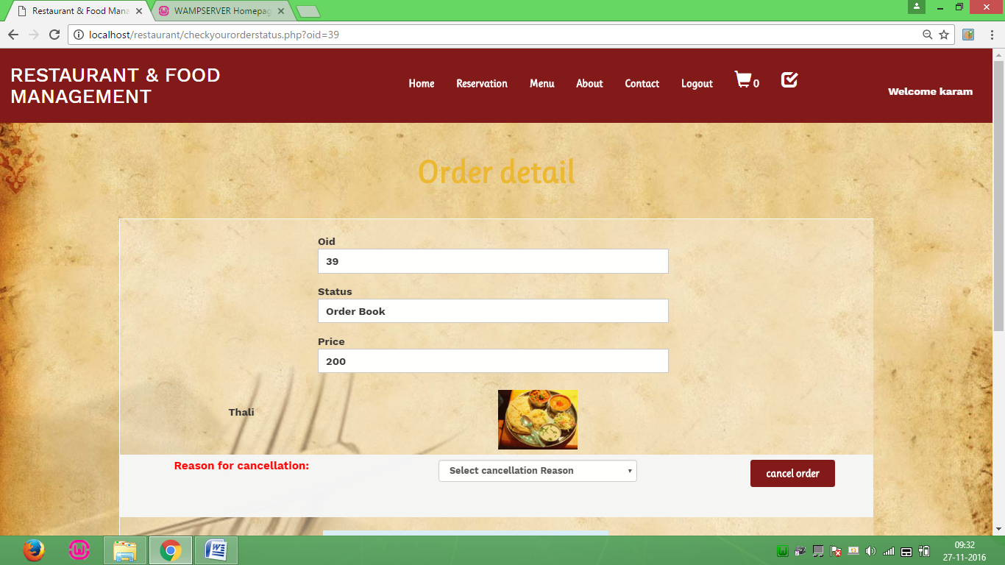Cancel order Screen Fig 8.12

**Cancelled order detail**

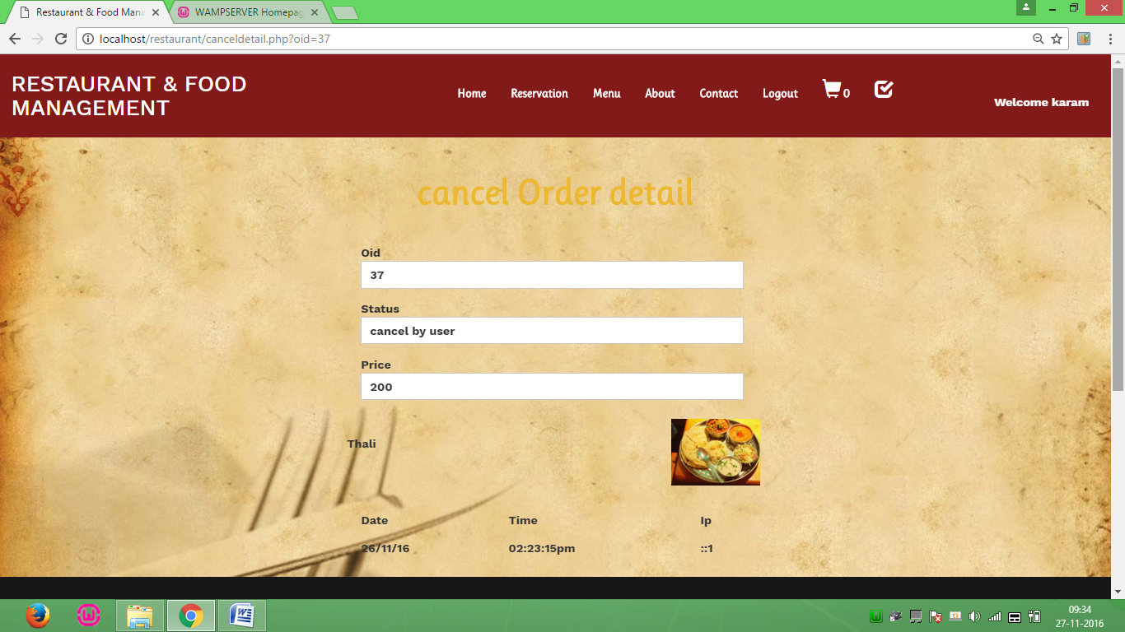Cancelled order detail Screen Fig 8.13

**My order detail**

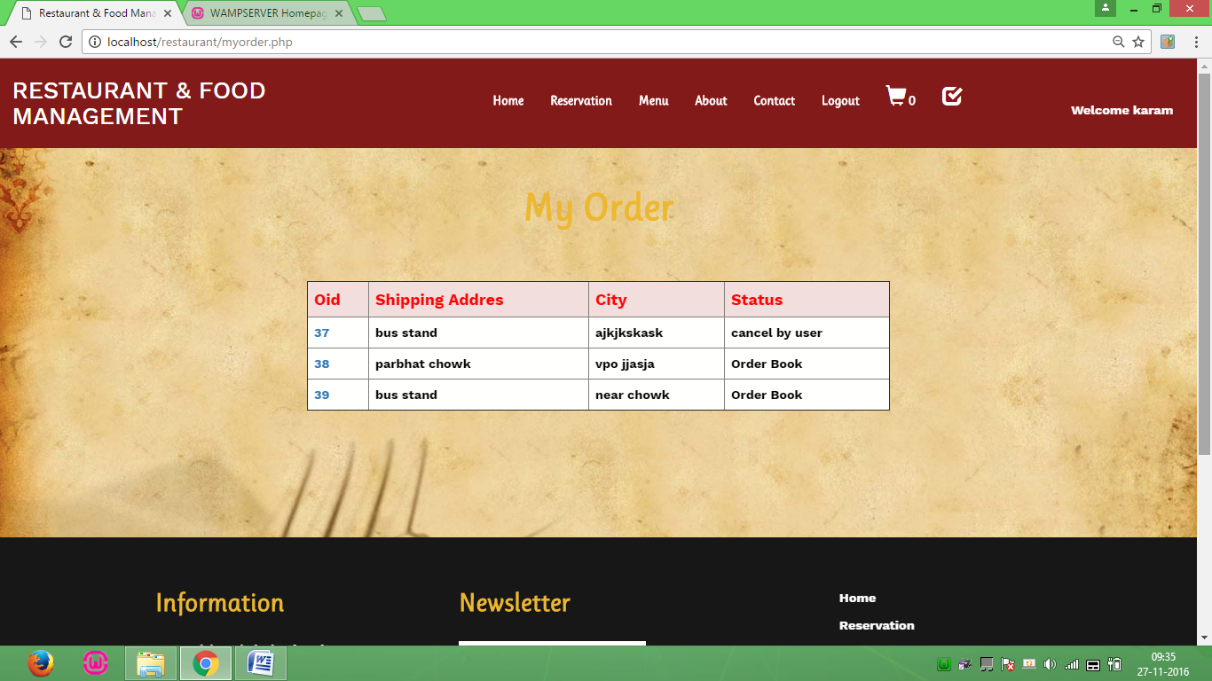My order detail Screen Fig 8.14

**Reservation**

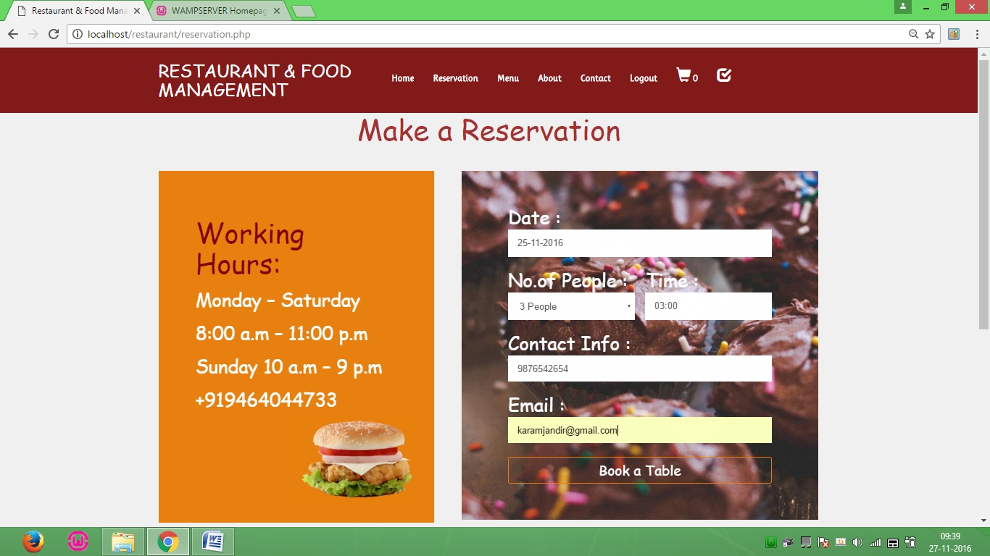Reservation Screen Fig 8.15

**Admin Login**

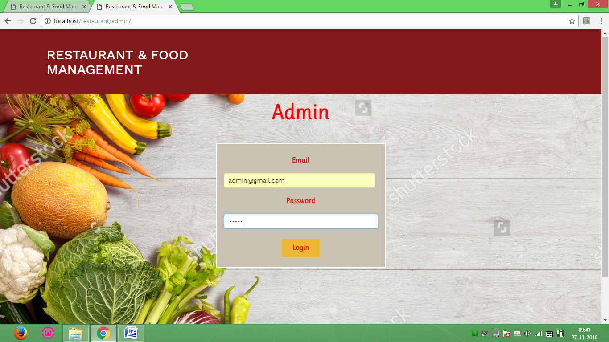

Admin login Screen Fig 8.16

**Welcome Page**

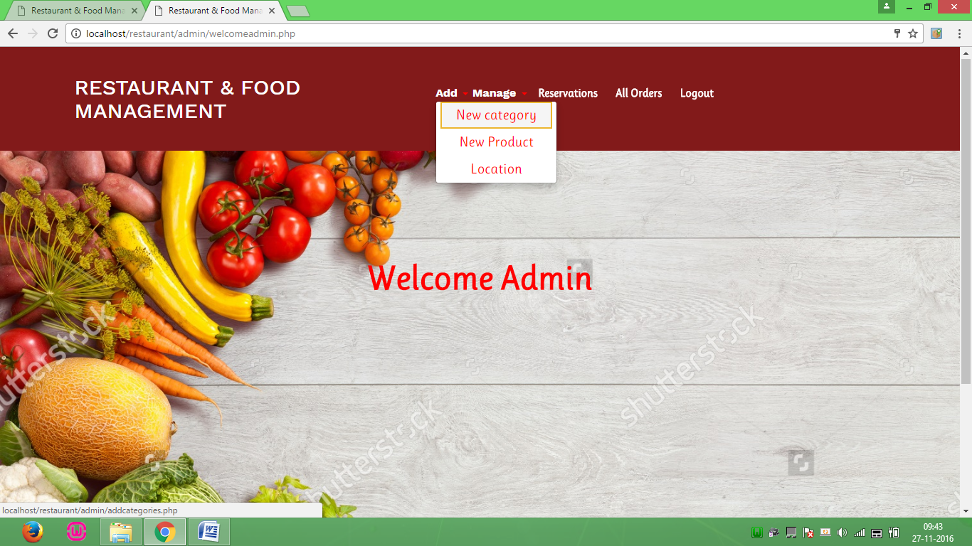Welcome Page screen Fig 8.17

**Add category**

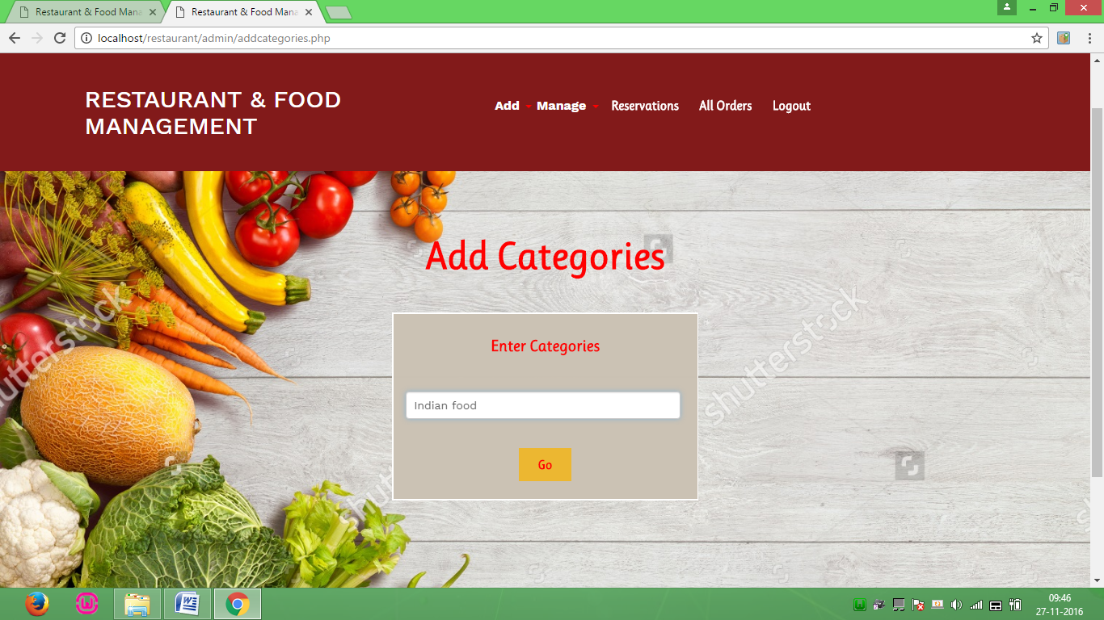Add category screen Fig 8.18

**Add product**

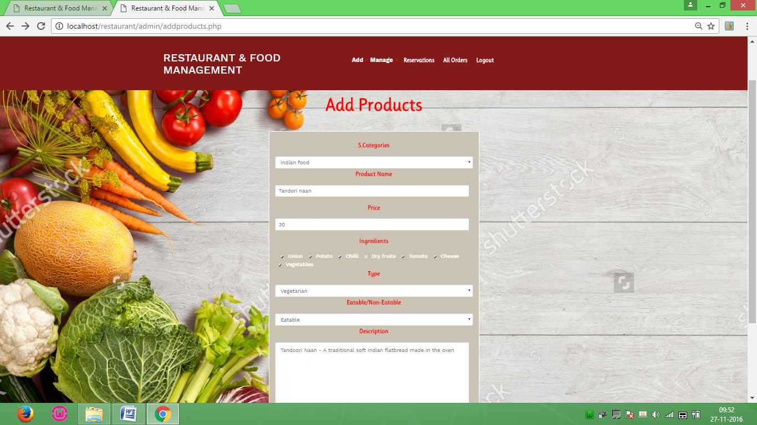Add product Screen Fig 8.19

**Add Location**

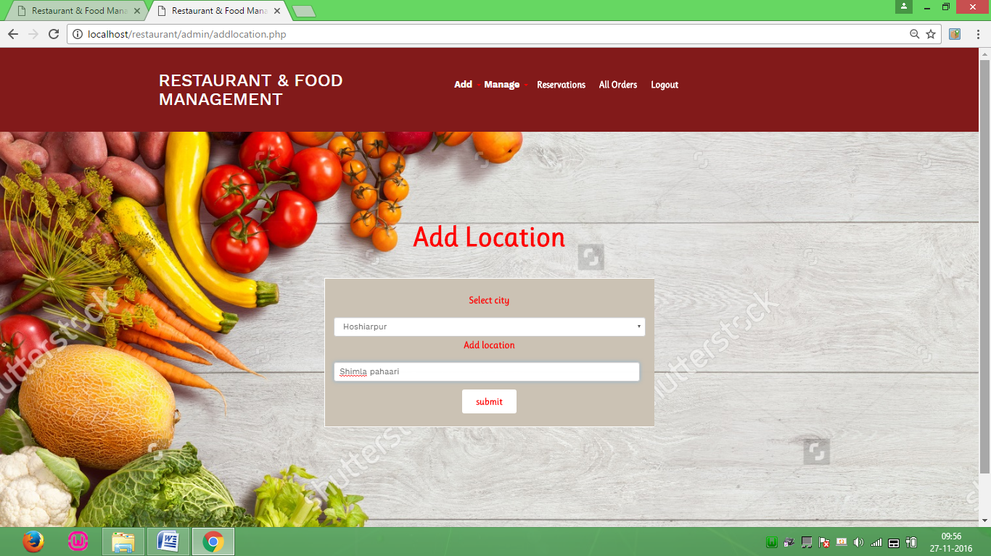Add location Screen Fig 8.20

**Manage Category**

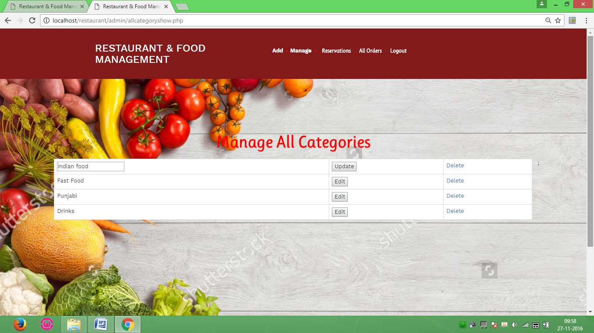

Manage category Screen Fig 8.21

**Manage Product**

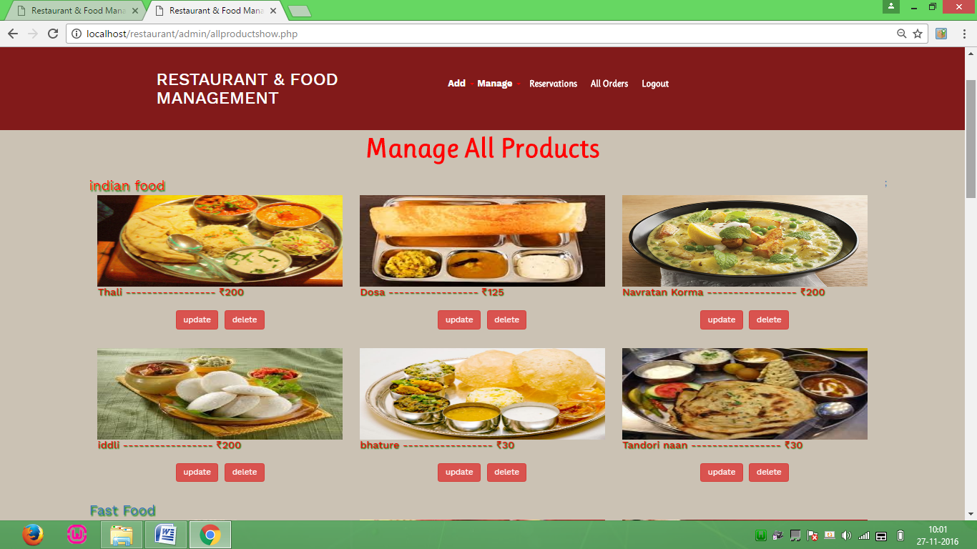Manage product Screen Fig 8.22

**Reservation**

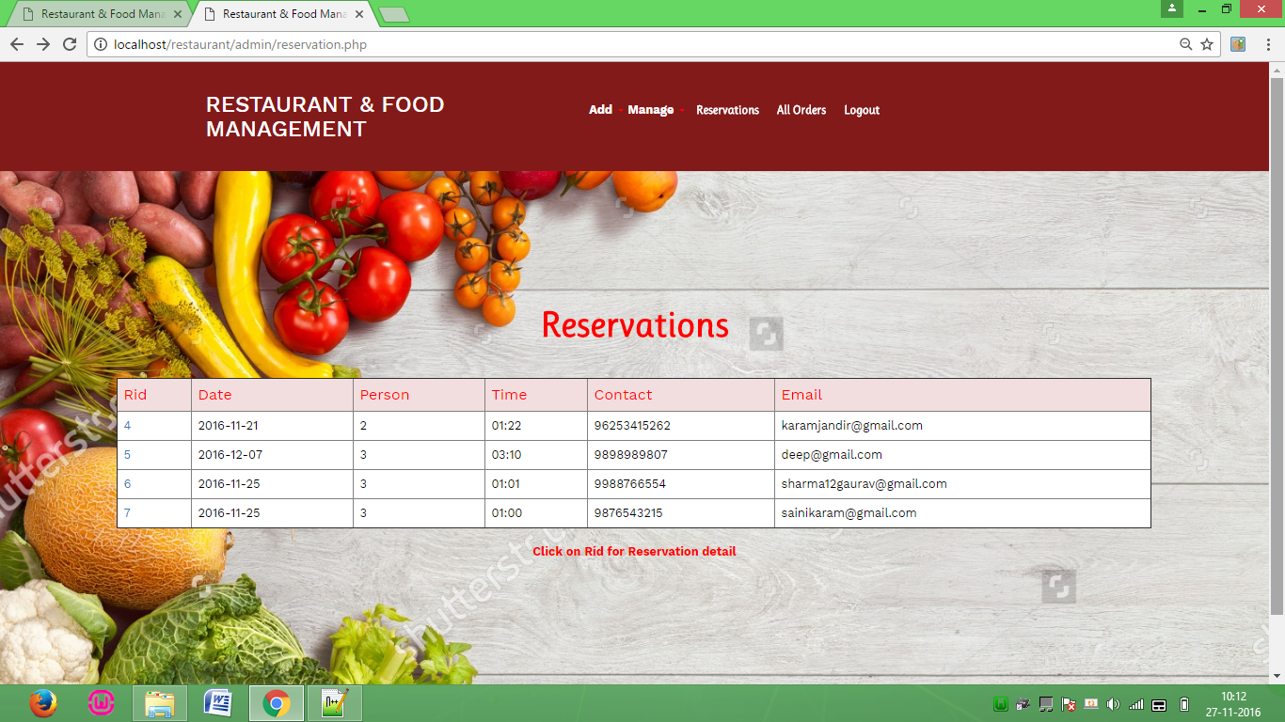Reservation Screen Fig 8.23

**Send mail**

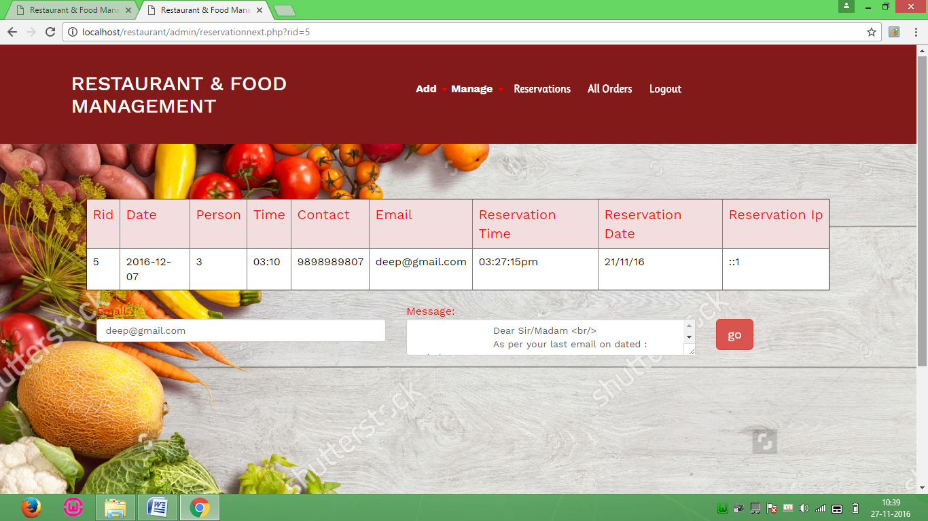Send mail Screen Fig 8.24

**All order**

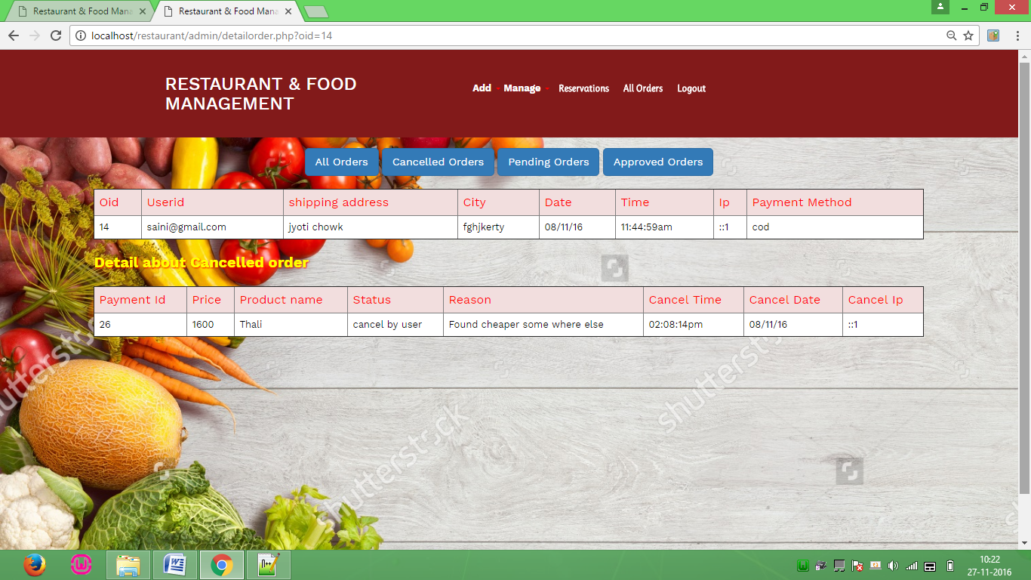All order Screen Fig 8.25

**All Cancel order**

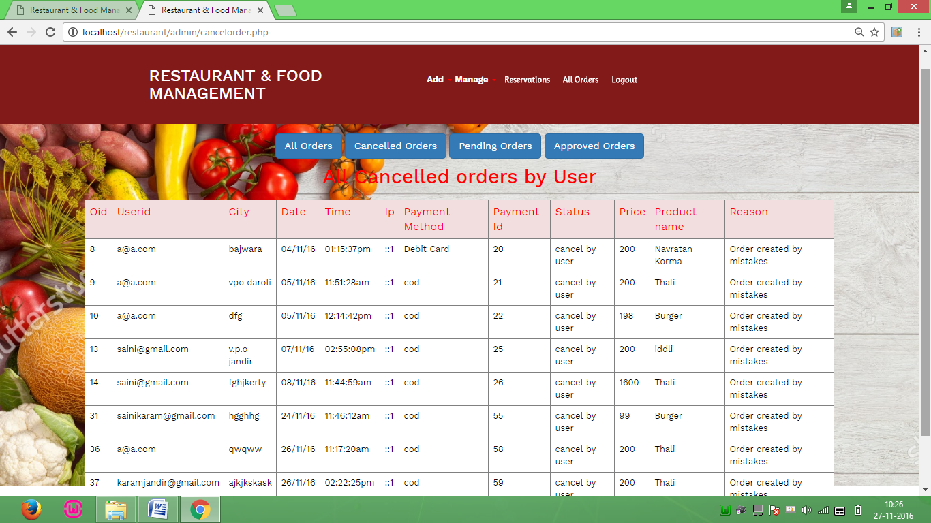All cancel order screen Fig 8.26

**Pending order**

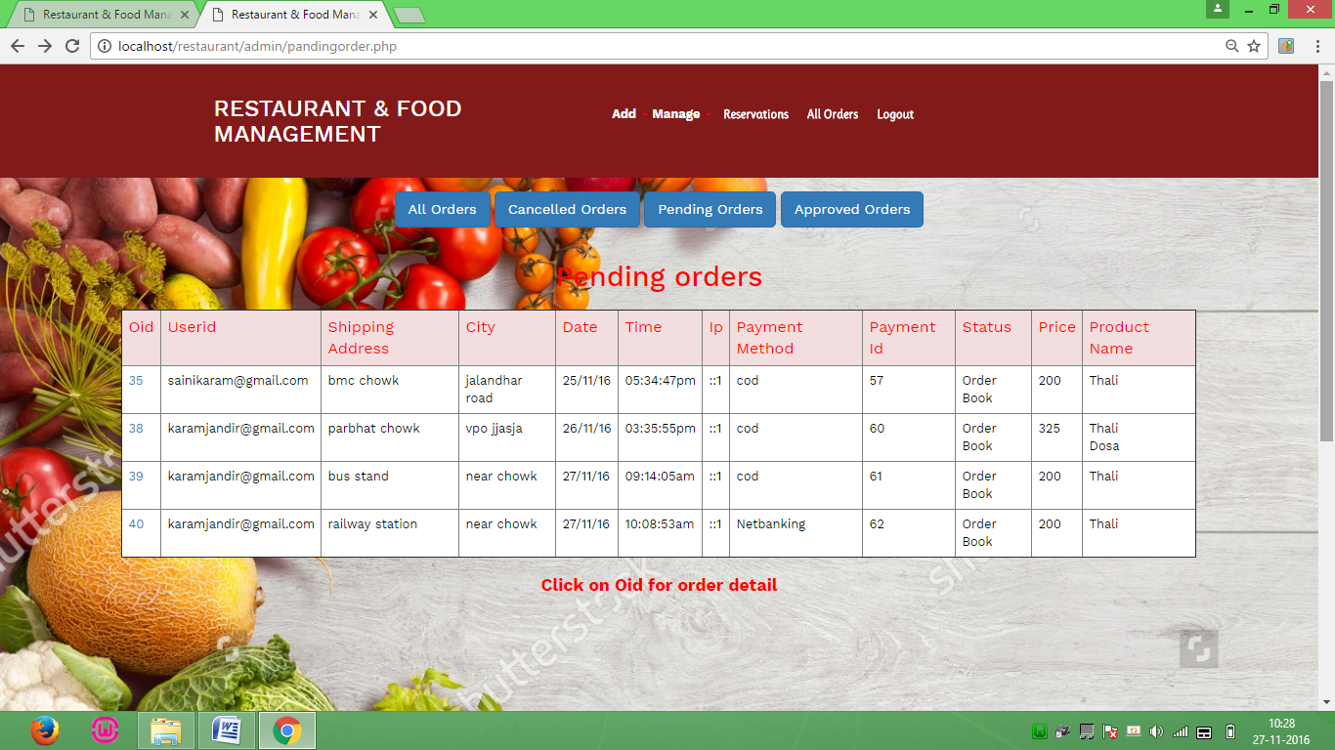Pending order Screen Fig 8.27

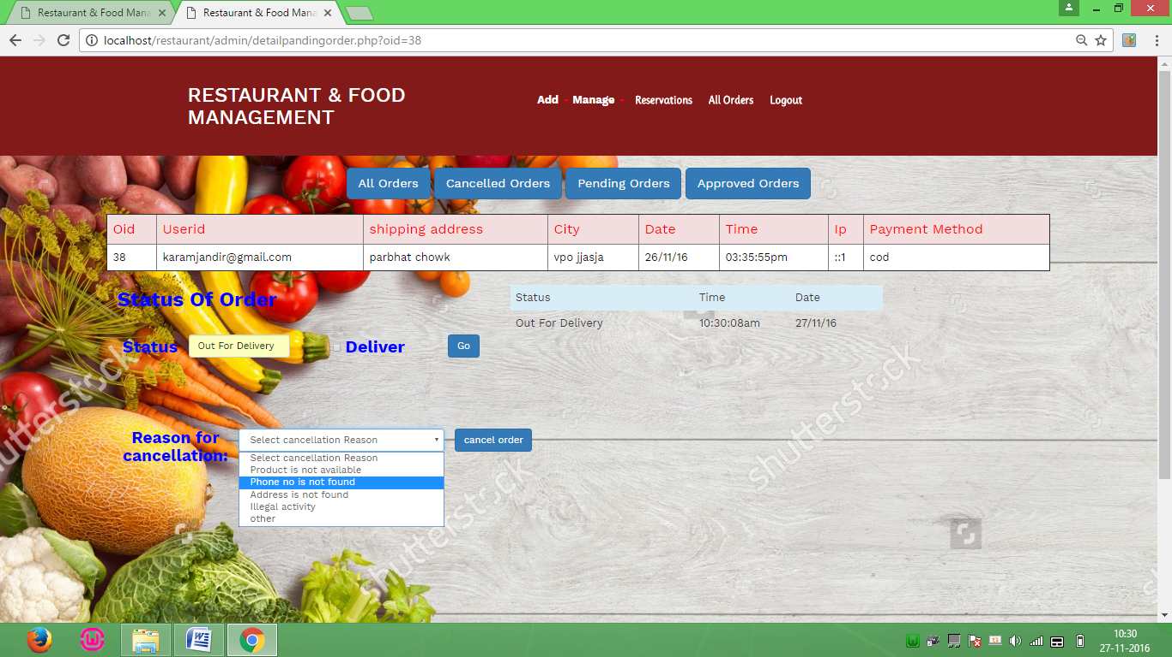

Pending order detail Screen Fig 8.28

**Approve order**

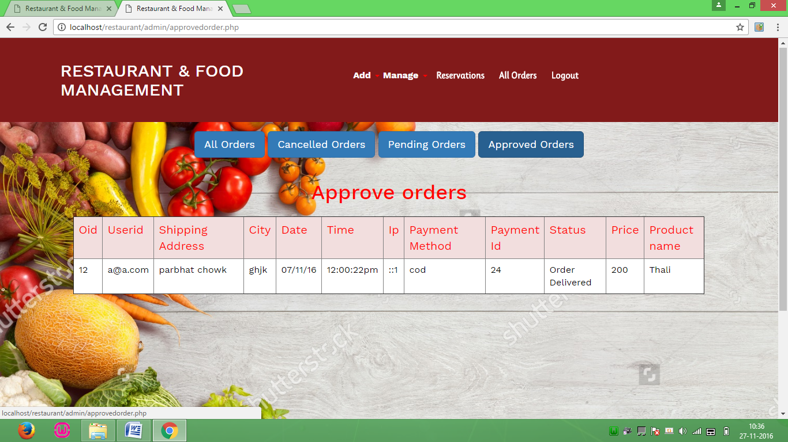

Approve order Screen Fig 8.29

**Database Page**

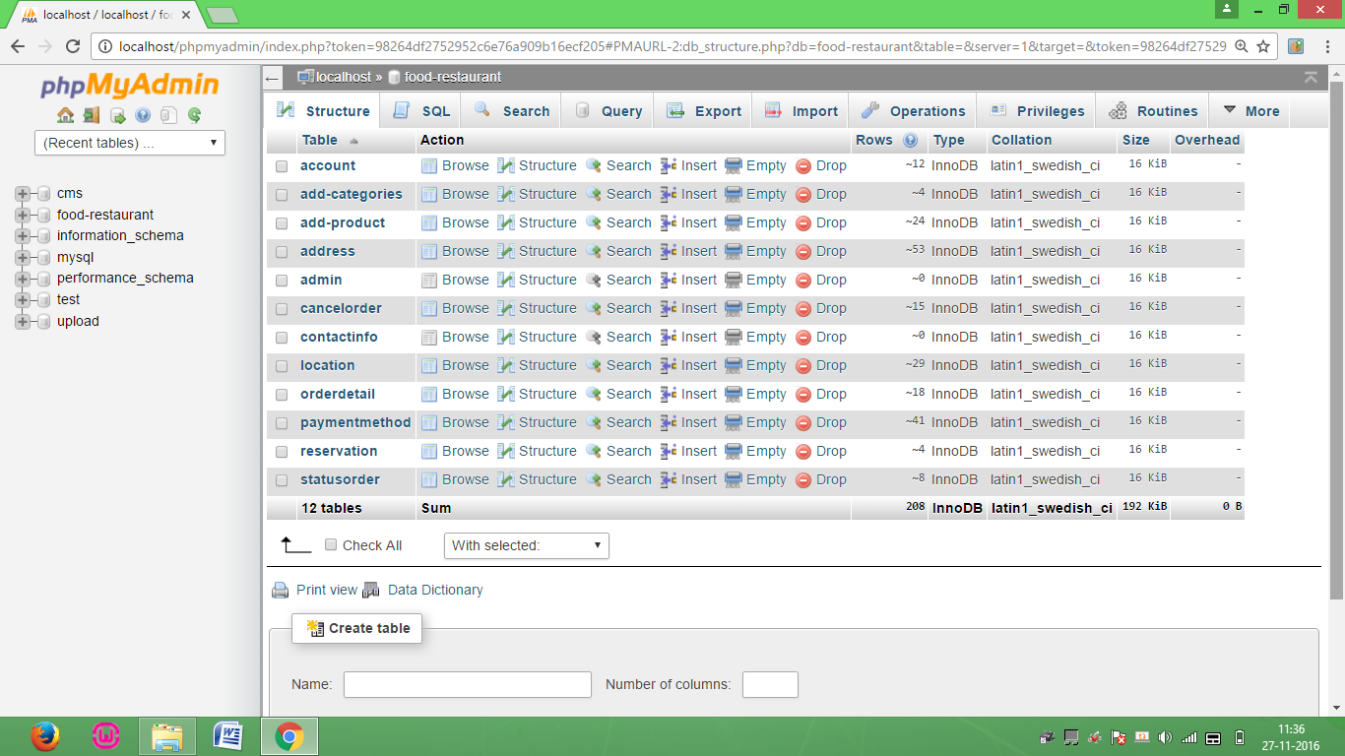

Database Screen Fig 8.30

**Chapter 9**

**System Implementation and Testing**

**9.1 Implementation**

Implementation is the status of the project when the theoretical designs turned into a working system. It is the process of converting a new revised system in to an operational one. It is the key stage in achieving a successful new system because usually it involves a lot of upheaval in the use department. It must therefore carefully plan and controlled so as to avoid chaos.

Apart from planning, the two major task of preparing for implementation are education and training of users and testing of system. Education of users should really have taken place much earlier in the project when they were being involved in the investigation and design work.

The user staff has been given necessary training for using the system. The training has made them to get acquainted with the system. The development any system results in success only when the system is implemented properly.

**9.2 Testing**

Testing is one of the major hurdles in the development of the system. Testing is the process of fining errors in the system. Only error-free website will be stable for a long time. There are different types of techniques for finding the bugs in website.

System testing is the major quality control measure during software development. A series of test cases are generated that is intended to demolish the software that has been built. Testing is a set activity that can be planned and conducted schematically. Testing begins at the module level and work towards the integration of entire computer based system.

Testing is a process of executing a program with the intention of finding an error. A good test case is one that has a higher probability of finding an undiscovered error. A successful test case is one that uncovers an undiscovered error. Nothing is complete without testing, as it the vital success of the system.

**Testing Objectives**

There are several rules that can serve as testing objectives. They are

* Testing is a process of executing a program with the intent of finding an error.
* A good test case is one that has high probability of finding an undiscovered error.
* A successful test is one that uncovers an undiscovered error.

If testing is conducted successfully according to the objectives as stated above, it would uncover errors in the software. Generally by testing we are verifying the following three aspects.

* Testing for correctness
* Testing for implementation efficiency

**Chapter 10**

**CONCLUSION & FUTURE SCOPE**

**10.1 CONCLUSION**

The system has been developed for the given condition and is found working effectively. The developed system is flexible and changes can be made easily whenever required. Using the facilities and functionalities of php, the software has been developed in a neat and simple manner, thereby reducing the operator’s work.

The speed and accuracy are maintained in proper way. The user-friendly nature of this software developed in PHP framework is very easy to work with both the higher management as well as other users with little knowledge of computer. The results obtained were fully satisfactory from the user point of view.

The system was verified with valid as well as invalid data in each manner. The system is run with an insight into the necessary modifications that may be required in the future. Hence the system can be maintained successfully.

The project has been completed successfully with the maximum satisfaction of the organization. The constraints are met and overcome successfully. The system is designed as like it was decided in the design phase. The project gives good idea on developing a full-fledged application satisfying the user requirements

**10.2FUTURE SCOPE**

Completion of development process will result in a software package that will provide user-friendly environment, which is very easy to work with, even for people with very little knowledge of computer.

Management of various tasks is incorporated in the package and will deliver the required information in a very easy to access manner.

This package will provide accuracy, efficiency, speed and easiness to the end user. Since the system is verified with valid as well as invalid data and is run with an insight.

**Chapter 11**

**Bibliography**

* [**www.google.com**](http://www.google.com)
* [www.jqueryui.com](http://www.jqueryui.com)
* **www.w3school.com**
* [**www.Bootstrap.com**](http://www.scribd.com/pages?/emp)
* [**www.php.net**](http://www.php.net)
* **www.w3schools.in**
* **www.tutorialspoint.com**